|  |
| --- |
| SKIB352 Home Assignment |
| Business Analysts and Disruption |
| A critical evaluation of Business Analysts’ role in disruptive business models |

|  |
| --- |
| Ashley Honeycutt  25-11-2022  Word Count: 2042 |

Table of Contents

What is Disruption and what are Business Analysts? 2

Example of a Disruptor: AirBnb 3

The Business Analyst’s Role in Disruption 3

Modeling and Mapping 3

The Blue Ocean Strategy’s Four Action Framework 4

Business Process Mapping 4

RACI matrixes for Stakeholder Management 4

Use Technology to your Advantage 5

Data Analytics 5

Automation 6

Interpret your Data from all Angles 6

SWOT Analysis 6

Ethical Dilemmas of the Disruptive Business Analyst 7

Conclusion 8

Bibliography 9

# What is Disruption and what are Business Analysts?

Since its initial coining by Clayton Christensen, an American business consultant, disruption – or disruptive innovation – has been frequently misunderstood and misapplied. A consequence of this is that business managers may use the wrong tools in their efforts to build or challenge a disruptive business, resulting in lower chances of success. It is important to understand the intended meaning of disruptive innovation, so we will begin by defining it (Christensen, Raynor and McDonald, 2015).

The process of disruptive innovation begins with the incumbents (existing companies) of a particular industry. The incumbents are catering their product or service to the mainstream consumer, and competition between them drives them to level-up their appeal to the high end of the market. The lower end of the market is overlooked, and that is where an entrant company can find access. The entrant is often small and has fewer resources, but successfully manages to appeal to this forgotten segment of the industry’s market. Over time, the entrant improves their performance and their appeal widens to the mainstream. Disruption occurs once the mainstream market widely favors the entrant company. Disruptors can also enter the scene by creating an entirely new market. The trajectories of incumbents and disruptors are displayed on the graph below, created by Christensen (Christensen, Raynor and McDonald, 2015).

What is the business analyst’s role in disruptive innovation? In broad terms, a business analyst is a professional who analyzes past and present data in order to optimize decision-making for a company’s future (DiFranza, 2019). In the context of an incumbent, a business analyst should be equipped to identify newcomers on a disruptive trajectory, as they may pose a serious threat to the incumbent business. This involves being able to discern smaller companies who do not pose a threat from those who do. For the entrant companies aiming to disrupt, a business analyst is tasked with identifying the unserved market and their needs, and optimizing the product offering so the company can eventually grow to reach the mainstream. There are many tools business analysts can use in the aim of disruption, and we will analyze them in the context of a disruptor: AirBnb.

# Example of a Disruptor: AirBnb

AirBnb had humble beginnings as a small network of cash-strapped San Franciscans hosting guests on air mattresses. The founders saw an opportunity to make a few extra dollars when a large conference in the city resulted in most of the hotels being fully booked, and there were numerous attendees with no place to stay. Initially, their simple website called AirBedandbreakfast.com attracted a small number of guests. Over time, the network of hosts and guests expanded and the online platform grew until AirBnb became a popular choice for mainstream travelers, thus becoming a disruptor of the hospitality industry (Kylliäinen, n.d.).

# The Business Analyst’s Role in Disruption

It is doubtful that the founders of AirBnb had ambitions to disrupt the hospitality industry when they seized that initial opportunity to host conference attendees in their apartments. But the origins of AirBnb have the makings of an entrant on a disruptive trajectory. Specifically, they were able to identify an unserved market (conference attendees who could not find a hotel room or did not wish to pay a high price) and give them an adequate service at a low price (air mattresses in their private apartments). They catered to the low end of the market, while hotels catered to the mainstream and high end. This is a key skill for a disruptive business analyst: to be able to analyze a market and identify the unserved portion, and to understand the unserved portion’s needs in order to provide them an adequate service.

Another key skill for a disruptive business analyst is to be constantly aware of existing and emerging technologies. AirBnb’s beginnings seized on the rise of the internet. Using a webpage to advertise their service capitalized on the internet’s growing popularity at the time and showed an understanding of the tech-oriented nature of their target market.

In order to successfully grow AirBnb or any entrant company to the mainstream, there is a toolkit business analysts can use to continually assess, adjust, and implement their disruptive business strategy.

## Modeling and Mapping

As a starting point, maps and models help a business analyst visualize the structure of a company and its stakeholders. Having this information organized visually helps inform the sequence of actions a company must take in order to achieve its disruption goals.

### The Blue Ocean Strategy’s Four Action Framework

There are many formats for business mapping, but for a disruptor, a valuable one is The Blue Ocean Strategy’s Four Action Framework because it helps analysts identify the ways they wish to differentiate their product from the industry norms, and concurrently facilitates an analysis of the market. This model requires the analyst to describe the factors in their business they aim to reduce, create, raise, and eliminate from the industry norms (Blue Ocean, 2013).

Four Action Framework: AirBnb Example:

Reduce: cost, service fees

Create: reliable (reviewed and verified) network of hosts and guests around the world on an easy-to-use platform, opportunity for property-owners to earn

Raise: personal connection, local integration, space, variety

Eliminate: costly amenities like daily housekeeping, room service

### Business Process Mapping

Process mapping uses symbolic flow charts to visually display the lifecycle of each important business process in a company. Software like Microsoft Visio or BPMN can be used for process mapping. It helps to identify redundancies and inefficiencies, which can then be eliminated to help the company grow. Efficient operation is key for the growth of a disruptive entrant (SearchCIO, n.d.).

(SearchCIO, n.d.)

### RACI matrixes for Stakeholder Management

Disruptive business analysts must be aware of all stakeholders both internal and external and the roles they play in the company. A helpful tool for understanding the role of each stakeholder is a RACI chart, which identifies the tasks each stakeholder is responsible for, accountable for, consulted on, and informed of. Seeing the responsibilities visually charted also helps to identify workload imbalances. Fixing these will help increase employee satisfaction and therefore enhance company performance (pmtips.xyz, n.d.).

(pmtips.xyz, n.d.)

## Use Technology to your Advantage

### Data Analytics

The foundation of business analysis is data. Once your business processes, stakeholders, and goals are mapped, use them to design a data analytics hub. Implement an integrated analytics hub at your company that is shared with all members of staff. Universal access to integrated (opposed to siloed) data will improve collaboration and streamline decision-making across the board. Educating staff on the interpretation of data (or hiring staff with this skill) will build a team that is up for the challenge of innovation. Provide data and visualizations on the past and present of your company, its competitors, and industry. Companies like IBM and Salesforce (which are disruptors themselves) help integrate data and design custom analytics software for companies (Journey to AI Blog, 2022).



Example of a company’s data dashboard designed by Salesforce. All employees can use the dashboard to view up to date KPIs.

(www.datapine.co.uk, n.d.)

### Automation

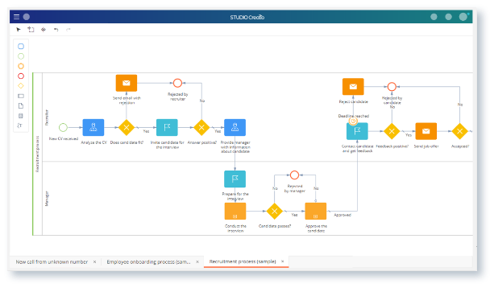Business Analysts can use Python to automate many business processes, which cuts costs and increases efficiency. Creatio software is another tool business analysts can use to automate business processes and manage customer relationships, and since it is a low-code platform, it is ideal for analysts without a tech background (www.creatio.com, n.d.).

Creatio software also utilizes process mapping flow charts. (www.creatio.com, n.d.)

## Interpret your Data from all Angles

Finally, a disruptive business analyst must interpret the data. Let’s remember what constitutes a disruptor in order to determine the questions we need to answer from the data.

A common mistake of new entrants seeking to disrupt is that they immediately aim to challenge the incumbents in their market. Christensen postulated that only 6% of businesses with this strategy manage to succeed (Christensen, Raynor and McDonald, 2015). Instead, in order to get on the disruptor trajectory an entrant must initially play to the portion of the market unserved by the incumbents. The entrant must examine the data and ask:

* Who are the incumbents serving?
* Who is unserved by the incumbents?
  + What are the desired product specifications of the unserved?
  + How can we deliver this product at a low price point?
  + What are the external factors affecting this market (cultural trends, economic trends, political events, etc.)?
* What is the business model of the incumbents?
  + How can we design a business model radically different from theirs?
  + How can we implement this business model with low investments?
  + How scalable is our model and how can we make it more scalable?

### SWOT Analysis

A helpful framework for analyzing a company’s data is SWOT: strengths, weaknesses, opportunities, and threats. Continually performing a SWOT analysis will help a company stay agile and on the disruptive trajectory (Shewan, 2020).

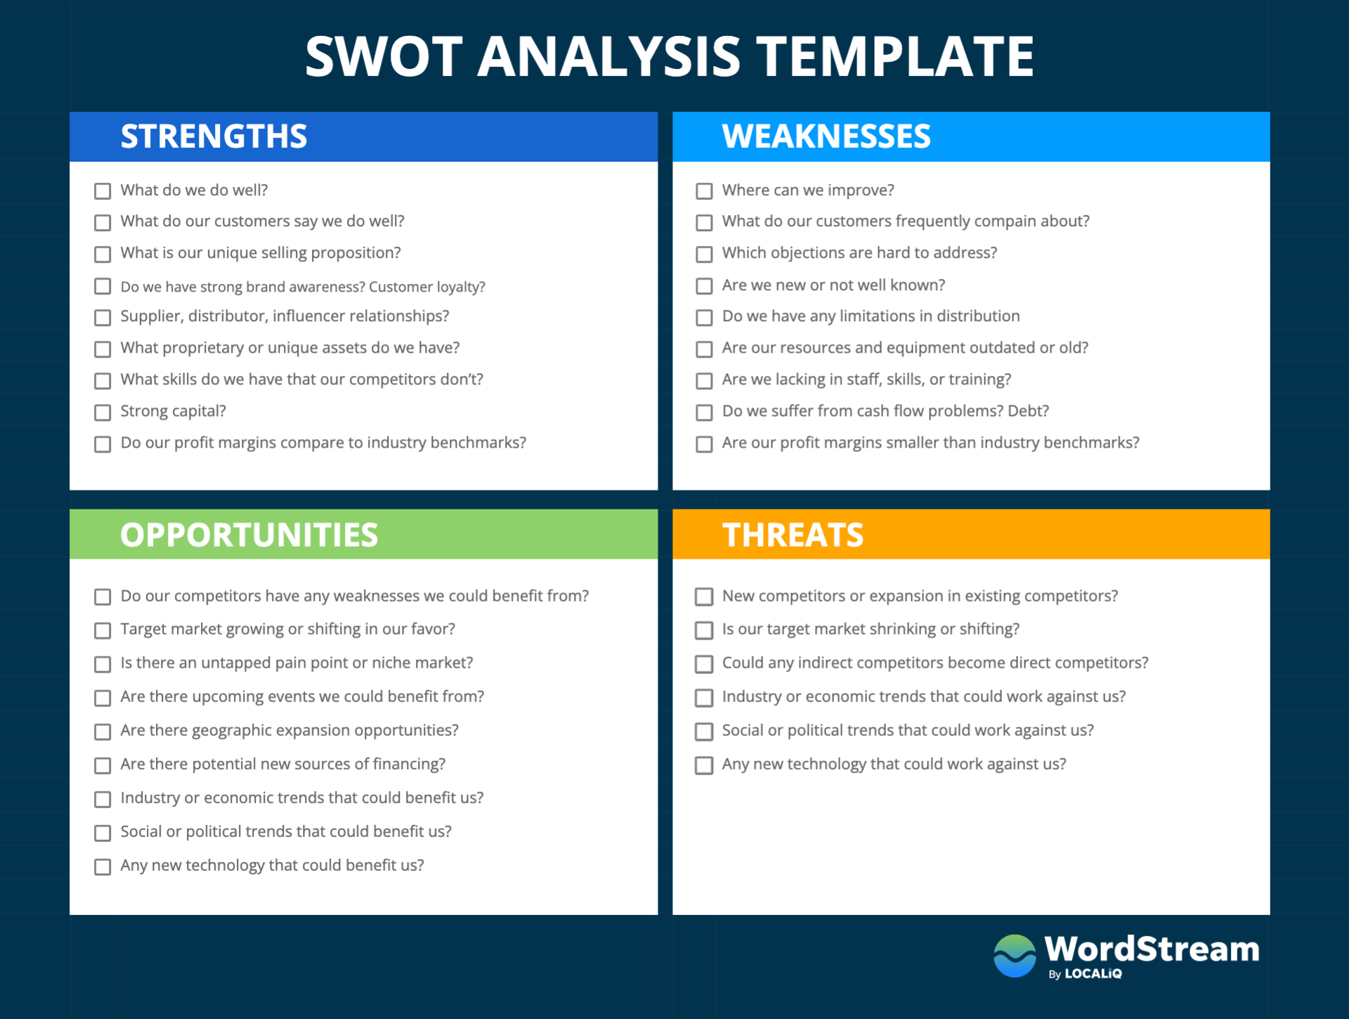

(Shewan, 2020)

Continually cycling through modeling and mapping, integrating, and analyzing data will ensure a company stays aware of changes as they happen and proactive in their implementation. This pattern of behavior can be described as agile, and a disruptor must always be agile.

# Ethical Dilemmas of the Disruptive Business Analyst

On its ascent, AirBnb notoriously created friction in the real estate market. Property owners all over the world saw high earning potential with AirBnb, and many properties in popular destinations were quickly purchased for the sole purpose of renting on AirBnb. This drove up property costs and priced out locals who could previously afford to live in the area. Properties that would have been allocated as low-cost rentals for locals were now used as AirBnbs for wealthier tourists (Kyosei Consulting, 2017).

Additionally, AirBnb regularly succeeds in avoiding the taxes and regulations of the hospitality industry by identifying as an internet platform rather than an actual hospitality business. This creates an unfair competition dynamic in the hospitality industry, since hotels are subject to these costly regulations (Kyosei Consulting, 2017).

Naturally, ethical dilemmas arise for disruptive innovators. Every company’s underlying goal is to maximize profit. As Shakespeare wrote, “one fire burns out another’s burning; one pain is lessened by another’s anguish” (Shakespeare, 2000). Where one experiences profit, another experiences loss. In AirBnb’s case, where one AirBnb host profits, a local loses a rental opportunity. For every advantage of a new technology, there is a disadvantage. For example, as cars improved human mobility and connectedness, they also increased environmental pollution.

How does a business analyst help balance a company’s goal of profit with the human desire to minimize harm? Regularly asserting your company’s values and checking if your business practices align with those values is key. In this process, it is important to consider feedback from all stakeholders. AirBnb professes to foster connection and community around the world, and it certainly does that by giving travelers vast opportunities for lodging. But do the locals feel more connected as they are priced out of local properties and as short-term renters invade their buildings without their consent (Kyosei Consulting, 2017)? It’s unlikely, and so AirBnb must address this value disparity. It is often necessary to sacrifice some potential profit in order to ensure regulations are being heeded, and that all stakeholders are adequately satisfied. In many cases, sacrificing some potential profit for good can be beneficial for the longevity of a company, as it keeps the public sentiment towards a company positive.

# Conclusion

To reiterate, being a disruptive business analyst initially requires identifying the unserved market of your industry and optimizing your business model to deliver that market a product that adequately satisfies their needs and price point demand. From that point forward, a business analyst must continually map their business model, its processes and stakeholders, collect and integrate data using the most current technologies, and analyze the data by asking the right questions in order to maintain a disruptive trajectory. After data is analyzed, analysts must be agile to implement changes based on the data. The foundation of disruption is change, and disruptive business analysts must be agile and adaptable to add value in this environment. Finally, in the ceaseless aim of profit maximization, disruptive business analysts must never lose sight of their company’s values, as companies that abide by their spoken values earn the respect, and therefore the business, of the public.

# Bibliography

Blue Ocean (2013). *Four Actions Framework: Reconstruct Buyer Value | Blue Ocean Strategy & Shift*. [online] Blue Ocean Strategy. Available at: https://www.blueoceanstrategy.com/tools/four-actions-framework/.

Christensen, C.M., Raynor, M.E. and McDonald, R. (2015). *What Is Disruptive Innovation?* [online] Harvard Business Review. Available at: https://hbr.org/2015/12/what-is-disruptive-innovation.

www.creatio.com. (n.d.). *CRM, low-code and process automation | Creatio*. [online] Available at: <https://www.creatio.com/>.

www.datapine.co.uk. (n.d.). *Salesforce Dashboards - Examples & Templates To Boost Sales*. [online] Available at: https://www.datapine.co.uk/dashboard-examples-and-templates/salesforce [Accessed 16 Nov. 2022].

DiFranza, A. (2019). *What Does A Business Analyst Do?* [online] Northeastern University Graduate Programs. Available at: https://www.northeastern.edu/graduate/blog/what-does-a-business-analyst-do/.

Journey to AI Blog. (2022). *Business Analytics in the age of disruption*. [online] Available at: https://www.ibm.com/blogs/journey-to-ai/2022/05/business-analytics-in-the-age-of-disruption/ [Accessed 16 Nov. 2022].

Kylliäinen, J. (n.d.). *Disruptive Innovation – What is It and How Does It Work?* [online] www.viima.com. Available at: https://www.viima.com/blog/disruptive-innovation#:~:text=Netflix%20is%20a%20classic%20example%20of%20disruptive%20innovation [Accessed 16 Nov. 2022].

Kyosei Consulting. (2017). *The Ethics of Disruption*. [online] Available at: <https://kyoseiconsulting.com/the-ethics-of-disruption/>.

pmtips.xyz. (n.d.). *Stakeholder analysis using RACI charts | Project Mangement Tips*. [online] Available at: https://pmtips.xyz/2020/06/21/stakeholder-analysis-using-raci-charts/.

‌

SearchCIO. (n.d.). *What is Business Process Mapping?* [online] Available at: https://www.techtarget.com/searchcio/definition/process-mapping.

‌

Shakespeare, W. (2000). *Romeo and Juliet*. Oxford: Oxford University Press.

Shewan, D. (2020). *How to Do a SWOT Analysis for Your Small Business (with Examples)*. [online] Wordstream.com. Available at: <https://www.wordstream.com/blog/ws/2017/12/20/swot-analysis>.

‌